Multimedia Systems and Applications
Final Exam
(Question Bank)

- (15%) Arithmetic Coding and Huffman Coding are two popular lossless compression methods. Suppose the alphabet is [A,B,C], and the known probability distribution is P_{A} = 0.5, P_{B}=0.4, P_{C} = 0.1. For simplicity, let’s also assume that both encoder and decoder know that the length of the messages is always 3, so there is no need for a terminator. (7-5b)
(1) How many bits are needed to encode the message BBB by Huffman coding?
(2) How many bits are needed to encode the message BBB by arithmetic coding?

- (10%) Given a very simple dictionary, initially containing only three characters, with the codes as follows:
Code String
- A
- B
- C
Now if the input string is ABABBABCABABBA, what is the output code based on the LZW compression algorithm. Please show how the LZW works. (Example 7.2)

- (15%) In Arithmetic Coding, suppose the alphabet is [A, B, C, D, E, F, $], in which $ is a special symbol used to terminate the message, and the known probability distribution is shown in the following table.

Symbol | Probability | Range
A | 0.2 | [0, 0.2)
B | 0.1 | [0.2, 0.3)
C | 0.2 | [0.3, 0.5)
D | 0.05 | [0.5, 0.55)
E | 0.3 | [0.55, 0.85)
F | 0.05 | [0.85, 0.9)
$ | 0.1 | [0.9, 1.0)

What is the generated binary code word for the string of symbols BED$ after Arithmetic Coding? (Page 189)

- (15%) Consider the dictionary-based LZW compression algorithm. Suppose the alphabet is the set of symbols {0, 1}. Show the dictionary (symbol sets plus associated codes) and output for LZW compression of the input 0 1 1 0 0 1 1. (7-8)

- (5%) The logarithmic MV search method is suboptimal, in that it relies on continuity in the residual frame.
(a) Explain why that assumption is necessary, and offer a justification for it.
(b) Does the hierarchical search method suffer from suboptimality too? (10-5)

- (10%) Assume that the Adaptive Huffman Coding is used to code an information source S with a vocabulary of four letters (a, b, c, d). Before any transmission, the initial coding is a = 00, b = 01, c = 10, d = 11. As in the example illustrated in Fig. 7.7, a special symbol NEW will be sent before any letter if it is to be sent the first time. Fig. 7.11 is the Adaptive Huffman Tree after sending letters aabb. After that, the additional bitstream received by the decoder for the next few letters is 01010010101.
  - What are the additional letters received?
  - Draw the adaptive Huffman trees after each of the additional letters is received. (7-6)
4

2

2

0

2

0
1
0
1
b
a
NEW
Fig. 7.11: Adaptive Huffman Tree.
- (20%) The Huffman coding algorithm requires prior statistical knowledge about the information source and such information is often not available. The solution is to use Adaptive Huffman coding algorithm. Let’s assume the initial code assignment for both the encoder and decoder as follows.
Initial Code
NEW: 0
A: 00001
B: 00010
C: 00011
D: 00100
: :
For the symbol string AADCC,
- Please provide the Huffman tree after each step using the Adaptive Huffman coding algorithm.
- Please give the sequence of symbols and code (zeros and ones) being sent to the decoder. (Example 7.1)

- (10%) Given a very simple dictionary, initially containing only three characters, with the codes as follows:
Code String
- A
- B
- C
Now if the input string is ABABBABCA, what is the output code based on the LZW compression algorithm. Please show how the LZW works. (Example 7.2)

- (10%) Consider the Haar Wavelet Transform that replace the original sequence with its pairwise average x_{n-1,i} and difference d_{n-1,i} defined as follows.
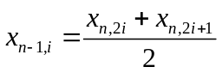, 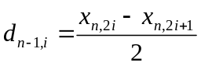
For the following input image, what is the output of the first level of the 2D Haar Wavelet Transform? (Example8.6)

0 | 0 | 0 | 0 | 0 | 0 | 0 | 0
0 | 0 | 0 | 0 | 0 | 0 | 0 | 0
0 | 0 | 120 | 60 | 60 | 120 | 0 | 0
0 | 0 | 60 | 200 | 200 | 60 | 0 | 0
0 | 0 | 60 | 200 | 200 | 60 | 0 | 0
0 | 0 | 120 | 60 | 60 | 120 | 0 | 0
0 | 0 | 0 | 0 | 0 | 0 | 0 | 0
0 | 0 | 0 | 0 | 0 | 0 | 0 | 0

- (15%) For the coefficients of a three-stage wavelet transform shown in the following figure, we attempt to code the coefficients using the EZW algorithm.

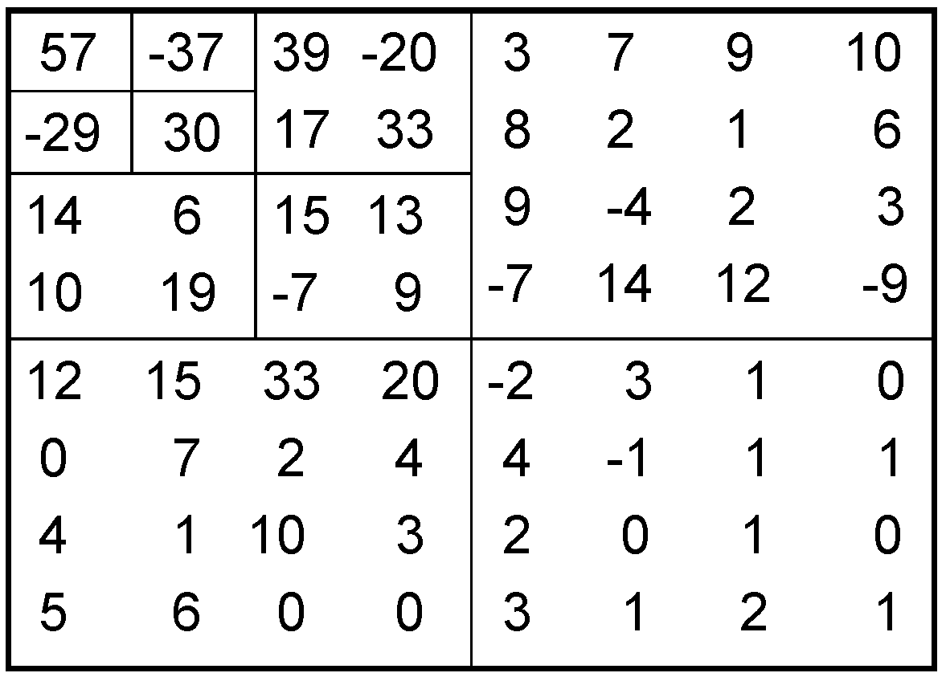
- What is the list of coefficients visited, in the order of the scan?
- What is the dominant pass outputs D₀?
- What is the subordinate pass output S₀? (8.8.3 example)

- (20%) Work out the following problem of 2D Logarithmic Search for motion vectors in detail (see the following figure).
The target (current) frame is a P-frame. The size of macroblocks is 4 x 4. The motion vector is MV(Δx,Δy), in which Δx[−p, p], Δy[−p, p]. In this question, assume p ≡ 5. The macroblock in question (darkened) in the frame has its upper left corner at (x_{t}, y_{t}). It contains 9 dark pixels, each with intensity value 10; the other 7 pixels are part of the background, which has a uniform intensity value of 100. The reference (previous) frame has 8 dark pixels.
(a) What is the best Δx, Δy, and Mean Absolute Error (MAE) for this macroblock?
(b) Show step by step how the 2D Logarithmic Search is performed, including the locations and passes of the search and all intermediate Δx, Δy, and MAEs. (10-4)
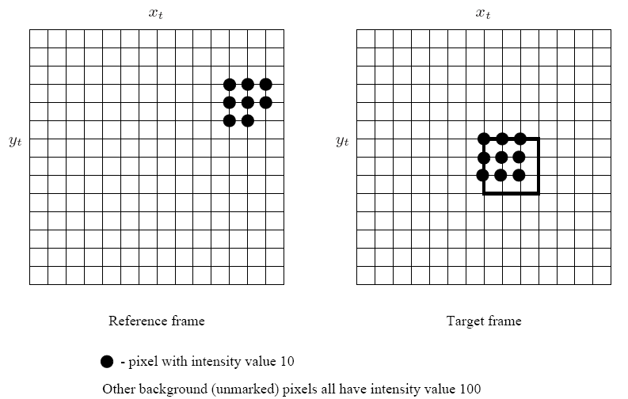

- (5%) When the block size is 8, the definition of the DCT is given in the following equation
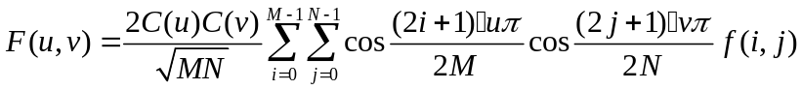
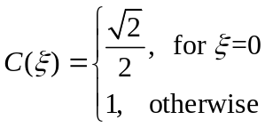
If an 8 x 8 grayscale image is in the range 0… 255, what is the largest value a DCT coefficient could be? Also, state all the DCT coefficient values for that image. (Hint: When the image is all WHITE, all pixels have I = 255) (8-5)

- (20%) Suppose that a 3-bit image (L=8) of size 64x64 pixels has the intensity distributions as follows.
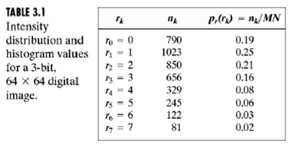
What is the intensity distribution S₀~S₇ after histogram equalization?

- (10%) Considering the effect of Frequency Masking, which descriptions are correct for the general situation in regard to masking?
( ) 1. A lower tone can effectively mask (make us unable to hear) a higher tone
( ) 2. A masking tone with greater power can mask the tone which is widely separated from the masking tone.

- (10%) Please give descriptions on the following speech coders.
- ADPCM
- Linear predictive coding

16. (5%) In the text, we study an adaptive quantization scheme for ADPCM. We can also use an adaptive prediction scheme. We consider the case of one tap prediction, (n) = a‧ s(n−1). Show how to estimate the parameter a in an open-loop method. (13-5)

